Data Extraction Software
(Version 2.9e)

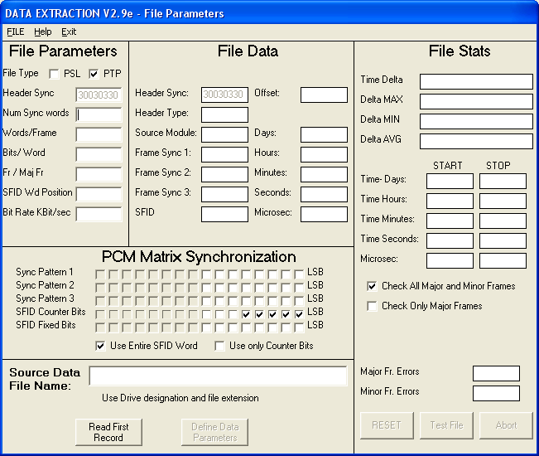

User’s Manual

Prepared By: Shelby Elborn

March 2, 2007

Proprietary property of NASA’s Sounding Rocket Operations Contract (NSROC) and may not be used copied, or distributed for any purpose other than for which it is supplied without express written authority of NASA’s Sounding Operations Contract (NSROC).

Data Extraction Software V 2.9e

User’s Manual

- Software Installation 3
- Starting the Extract Program 3
- Program Operation 3
- General Operation 3
- File Parameters 4
- Entering File Setup Parameters 4
- Loading the File Setup Parameters From a Saved File 6
- Saving File Setup Parameters 7
- Data Source File Designation 7
- Data File Verification 7
- Read The First Record 7
- Test the Data File 7
- Data Parameters 8
- Extract Data Definition 8
- Standard Data 8
- Super-Com Data 9
- Non-Symmetrical Data 9
- Delete Item 9
- Clear Page 9
- T-0 Start Time 10
- Extract Output File Parameters 10
- Extract Start Time 10
- Extract Stop Time 10
- Requested Sample Rate 10
- Requested number of lines in the output File 11
- Output File Name 11
- Enable GMT Format 11
- Enable Micro Second Timing 11
- Time Tag Each Word 11
- Output the Minor Frame Number 12
- Description File 12
- Time Stamps 12
- Frame 14
- Data Extraction 15
- Extraction Algorithm 15
- Description File 16
- Data Extraction Software Uninstall 17
Appendix A
PTP MUX Header Format 18
Appendix B
Software Limits 19
Appendix C
Data Extraction Rates 20
Software Overview
The Data Extraction Users Manual describes the Data Extraction Software. It is designed to be used only with the PTP MUX Header format files using PB-4 Time Code Format (described in Appendix A) or the PSL data format. Currently the extract program is limited to the following:
1-3 Frame Sync words
1-128 Frames / major frame
1-1024 words / frame
8-16 bit data
30 extract data items (at one time)
30 nonsymmetrical data items
Millisecond or Microsecond Time Stamp
GMT Time Stamp
Fixed PTP header sync 30030330hex

I. Software Installation
- Open the “Extract Deploy” folder.
- Run setup.exe.
- Click Install.
- Program Group: Extract

II. Starting the Extract Program
- Select START menu
- Select Programs
- Select Extract (Program Group)
- Select Extract

Program Operation
- General Operation Summary
Once the program has been installed and started, enter the PCM matrix format and source data filename. All the necessary file and matrix parameters are on the first Extract page (File Parameters). When entering the source data filename, use the drive designation and file extension. PTP formatted files often have a “.RC1” extension and PSL files often use “.bin” extension. Click the file type, PSL or PTP. Click Read First Record. This will verify the data file and matrix formats. If no errors are observed, Click Define Data Parameters. Enter the data parameters for each desired data item. DO NOT SKIP LINES. If more than 10 items are desired, select More Data from the DATA menu item. Enter the additional data items and return to the Data Parameters page by selecting Continue from the DATA menu item. Enter the flight T-0 start time and the “T” time to start and stop the data extraction. Enter the desired number of lines in the output file. Enter the output filename with the drive designation and extension. Click ENTER to verify the data parameters entered. Click Auto Search Start Extract to begin the extraction process. All setup parameters can be saved from the File menu item on the File Parameters page.

- File Parameters
The file setup parameters describe the PCM matrix. All parameters must be specified before starting the extraction process.
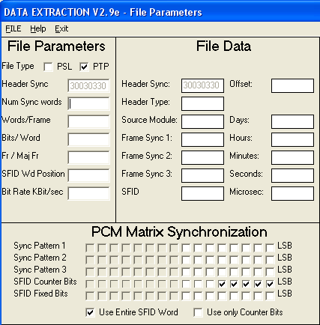

Entering File Setup Parameters

- File Type:
Describes the source file type. Select PSL for files created using the PSL logging format. Select PTP for files created using the PTP logging format.

- Header Sync:
This parameter is only valid with PTP formatted source data. The Header sync cannot be changed. This is the sync pattern generated by the PTP software and precedes each minor frame of data.

- Number of Sync Words:
Enter the number of Sync words used in the PCM matrix. This must be an integer number representing the number of whole sync words. Partial sync words cannot be used, ie. The upper portion of the SFID cannot be included in the number of sync words.

- Words Per Frame:
Enter the total number of words in each minor frame. This number must include frame sync words, the SFID word, and all data words in the minor frame.

- Bits Per Word:
Enter the number of bits in each data word. All data words must have the same number of bits per word.

- Frames Per Major Frame:
Enter the total number of minor frames per major frame.

- SFID Word:
Enter the word position of the SFID word. The first word after the last frame sync of each minor frame is word 1.

- Bit Rate:
Enter the bit rate of the PCM data in Kbit/sec.

- Sync Pattern:
Complete the “Bits Per Word” field and the “Number of Sync Words” field before entering the Sync Pattern. Enter the fixed sync pattern. This is a binary representation of the frame sync pattern. A “1” is represented with a check. “0” is represented with no check. Once the “Bits Per Word” field and the “Number of Sync Words” field have been completed, only active sync bits can be entered.

- SFID Counter Bits:
Enter the SFID counter bits. A check indicates that the bit is used for counting. Once the “Bits Per Word” field has been completed, only active SFID bits can be entered.

- SFID Fixed Bits:
Enter the SFID fixed bits. The fixed bits are bits that are part of the SFID word but that are always a logic “1”. A check indicates a "1". Once the "Bits Per Word" field has been completed, only active SFID bits can be selected.

- Use Entire SFID Word:
If selected, the entire SFID word will be used to identify frame data. This method includes the fixed bits in frame identification.

- Use Only SFID Counter Bits:
If selected, only the SFID counter bits will be used for to identify frame data. All fixed SFID bits will be set to "0" and not used for frame identification.

Loading File Setup Parameters From a Saved File
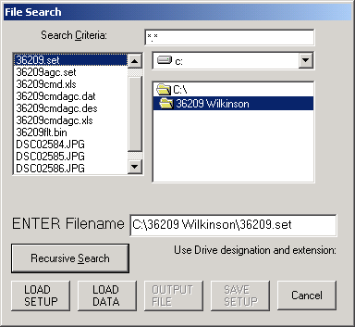
All matrix and data parameters can be loaded from a previously saved file. Select File and then select Load file. A file search form will display the drive, search field, and file list.

If the name and location of the setup file is known, simply type in the filename with the drive and extension designations, ie. C:\extract\36112.set. An alternative method is to use the file search feature. Select the drive designation from the drive list box. Double Click the directory to be searched, or double click on the drive designation to search the entire drive. Enter the search criteria. When this is entered, the highlighted directory will automatically be searched. To conduct a recursive search of all subdirectories beneath the selected directory or drive, click SEARCH. The found files will be displayed in the left file list. Click on the desired file and it will write the filename in the “ENTER File Name” text box. If a search was conducted, the form can be reset by clicking RESET. Load the setup file by clicking LOAD Setup.

Saving File Setup Parameters
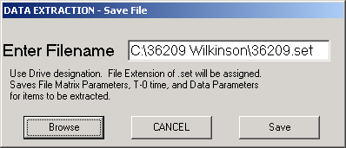
All file parameters and data parameters can be saved. Once the setup parameters have been completed, select Save Setup from the drop down File menu. Enter the file name using the drive designation and file extension. Setup files should be saved with a .set file extension.

Data Source File Designation
If the name and location of the source data file is known, simply type in the file name with the drive and file extension. If the file name or location is not known, use the search feature as described in “Loading File Setup Parameters From a Saved File”. After a search, click Load Data File.

- Data File Verification

A. Read the First Record
Before data parameters can be entered, verify the file and frame (setup) parameters. The setup parameters can be tested by reading the source data file. Click Read First Record. If all parameters are correct, the file will be read and all the file and matrix parameters will be displayed. If the file did not start with minor frame 1, or if any file parameter is incorrect, a SEEK ERROR will be displayed. Click Read Next Record several times to see if the SEEK ERROR is persistent. If it is, check the file parameters and repeat until no SEEK ERROR is displayed. Each time Read Next Record is clicked, the next major frame in the file is read. At least one record must be read before the Define Data Parameters button will become active. Select Define Data Parameters to open the Data Parameters page.

Test the Data File
The entire data file can be read to check for file errors. Each file record is checked for the PTP header, frame sync, SFID, and time. The file stats will display the file start time, stop time and time minimum delta, maximum delta, average delta, and current delta. Click Test File to read the entire data file. If all parameters are correct, the file will be read and all the file and matrix parameters will be displayed. Anytime an error is discovered in the data file PTP sync, File Sync or SFID, a SEEK ERROR will be displayed. The total number of major frame and minor frame errors will be displayed. Each time the Test File is clicked, the file is read from the beginning.

All the displayed file data and file stats can be reset by clicking Reset. The test file read process can be stopped at any time by clicking Abort.
DO NOT EXIT WHILE THE READ IS IN PROGRESS.

- Data Parameters
Open the Data Parameters page by selecting Define Data Parameters on the File Parameters page. The Data Parameters page is used to define the matrix locations of the data to be extracted. This panel is also used to define the T-0 time, start time, stop time, and define the format of the output file.

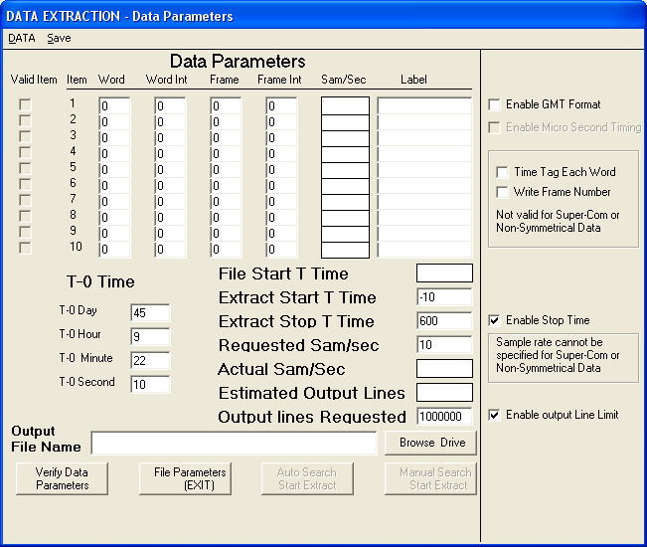

Extract Data Definition

Standard Data
Enter the word number, word interval, frame number, frame interval, and data label designation for each data item to be extracted. Word number 1 is the first word following the last frame sync. Each major frame begins with minor frame number 1. If more than 10 items are required, select More Data from the Data menu and enter values as previously described. When finished entering data items 11-30, select Continue from the DATA menu. Do not skip lines when entering data parameters. All entries will be written to the file in the order entered on the Data Parameters page.

Super-com Data
Enter the word number, word interval, frame number, frame interval, and data label designation for all data to be extracted. Word number 1 is the first word following the last frame sync. Frame number 1 is the first minor frame in the major frame. If more than 10 items are required, select More Data from the Data menu and enter values as previously described. When finished entering data items 11-30, select Continue from the Data menu. No item lines can be skipped. All entries will be written to the file in the order entered on the Data Parameters page.
All super-com data must have the same word interval rate. The word interval rate entered in Item 1 will be used for the interval rate of all entries. All super-com data will be extracted. Lower sample rates cannot be specified. Due to frame formatting of the PTP files, frame sync words are excluded from supercom data extraction. If the frame sync extraction is desired, use Non-Symmetrical data or directly enter the frame sync location in the parameters page.

Non-Symmetrical Super-com Data
Select Non Symmetrical Data from the data menu. Enter all nonsymmetrical data words separated by commas. No more than 30 words can be extracted at a time. All extracted data items can be written in the output file on one line with the time stamp of the minor frame or each entry can be written in the output file on a separate line with each data item time stamped. Click Time Stamp Each Item to generate a file with each data item time stamped. Select Continue to load the nonsymmetrical data. Nonsymmetrical data can be canceled by selecting Cancel Nonsymmetrical data from the data menu and then clicking Cancel Nonsymmetrical Data.

All non-symmetrical super-com data will be extracted. Lower sample rates cannot be specified.

Delete Item
Items can be deleted by selecting Delete Item from the Data menu. Items following the one deleted will be moved up on the page.

Clear Page
Select clear page to completely clear the data parameters page.

T-0 Start Time
The initial T-0 time will be set to the time designated by the first record of the data file. To change the T-0 time, enter the desired T-0 time of the flight on the Data Parameters page. Enter the number of whole days, whole hours, whole minutes, and seconds. A PSL formatted file often uses 0 for the number of days. Seconds can be entered as decimal fractions. The T-0 time is referenced to find the start "T" time of the extraction process.
The entered T-0 time is saved when the Setup File is saved and loaded when the Setup File is loaded. The T-0 time is only initialized to the first record if no T-0 time has been previously saved.

Extract Output File Parameters

Extract Start time
Enter the “T” time to start the extract process. This "T" time is referenced from the entered "T-0" time. The extract process will begin at the start of the file or at the extract start time, whichever occurs last.

Extract Stop Time
Enter the “T” time to stop the extract process. This "T" time is referenced from the entered "T-0" time. The extract process will terminate at the end of the file or at the extract stop time, whichever occurs first. If the start time occurs after the extract stop time, the stop time will automatically advance to 1 major frame past the start time.

Removing the check on the “Enable Stop Time” radio box will disable this feature and prevent the stop time from terminating the extract.

Requested Sample Rate
The requested sample rate is not valid when extracting supercom or nonsymmetrical data. Enter the desired number of samples per second to extract. This is only the desired value and the actual value may be different. The actual value is calculated based on the major frame rate.

Condition 1: The requested rate is < major frame rate and < lowest sample rate as defined by the data parameters. Not every major frame will be sampled. The samples taken will be taken on regular spaced major frames. Every X major frames will be sampled where X is calculated by:
M = Round (Major frame rate / requested sample rate)
Where Round is to the nearest whole number
X = M –1

The actual sample rate = major frame rate

M

Condition 2: The requested rate is > major frame rate and < lowest sample rate as defined by the data parameters: The number of samples to take for each major frame is calculated by:

Number Samples major frame = 1/ (Major Frame Rate / Requested Sample Rate)

Actual Sample Rate = number samples major frame * Major Frame Rate

Condition 3: The requested rate is > lowest sample rate as defined by the data parameters: Requested is set equal to lowest sample rate displayed in the data parameters.

- Requested number of lines in the output file.
Enter the desired number of lines in the output file. Entire Major Frames will be processed between each line check. If the number of lines requested has not been reached before a major frame is started, the number may exceed the requested number.

Removing the check in the “Enable output Line Limit” radio box will disable this feature and prevent the line limit from terminating the extract process.

- Output File Name
Enter the filename with the drive designation and file extension. All output files will be saved with a .dat file extension. If the name and location of the source data file is known, simply type in the file name with the drive and file extension. If the file name or location is not known, use the Browse Drive search feature as described in “Loading File Setup Parameters From a Saved File”. After a search, click Output File.

- Enable GMT Format
Checking the “Enable GMT Format” radio box will enable GMT formatted timing data. The timing data will be output as T-time, Day, Hour, Minute, Second.

- Enable Micro Second Timing
Microsecond timing can only be selected if GMT is enabled. If microseconds have been selected, the output format will include a microseconds field as follows:
T-time, Day, Hour, Minute, Second, Microsecond

- Time Tag Each Word
Each extracted word can be time tagged independently. Enable this feature by checking the “Time Tag Each Word” radio box.

- Output the Frame Number
The minor frame number for each word extracted can be included in the output file. Check the “Write Frame Number” radio box to enable this feature.

- Description File

A description file will automatically be generated after each extraction. It describes the parameters associated with the data extracted. The description filename will be the same as the output filename but will have a .des file extension.

- Time Stamps
The time stamp for the extraction program is based on the time stamp of the frame. The PTP format assigns a frame time using the first frame sync word as the start of the frame. There are three conditions that affect the time stamp.

Condition #1
If only 1 sample (of each data item to be extracted) is to be extracted from a major frame, the time stamp in the output file is the time of the first minor frame.

Condition #2
If multiple samples (of each data item to be extracted) are to be extracted from a major frame, the time stamp is based on the multiple interval. The time stamp of the first interval will always be the first minor frame. The time stamp of the second sample will be the time of the (interval + one) frame. The time stamp of the third sample will be the time of the ((interval * 2) + 1) frame. This method is continued until all intervals have been completed.

Example: If the major frame contains 32 minor frames and the data items to be extracted have an interval of 4 and all intervals will be extracted, the time stamps will be:
Minor Frame 1 time = interval 1 time stamp
(Interval 1 contains all data in minor frames 1, 2, 3, 4)
Minor Frame 5 time = interval 2 time stamp
(Interval 2 contains all data in minor frames 5, 6, 7, 8)
Minor Frame 9 time = interval 3 time stamp
(Interval 3 contains all data in minor frames 9, 10, 11, 12)

Minor Frame 13 time = interval 4 time stamp
(Interval 4 contains all data in minor frames 13, 14, 15, 16)

Minor Frame 17 time = interval 5 time stamp
(Interval 5 contains all data in minor frames 17, 18, 19, 20)
Minor Frame 21 time = interval 6 time stamp
(Interval 6 contains all data in minor frames 21, 22, 23, 24)
Minor Frame 25 time = interval 7 time stamp
(Interval 7 contains all data in minor frames 25, 26, 27, 28)

Minor Frame 29 time = interval 8 time stamp
(Interval 8 contains all data in minor frames 29, 30, 31, 32)
Frames/Major frame = 32
Frame interval for data to be extracted = 4
1
2
3
4
5
6
7
8
9
10
11
12
13
14
15
16
17
18
19
20
21
22
23
24
25
26
27
28
29
30
31
32

Any and All data extracted from this area will be time stamped minor frame 1
Any and All data extracted from this area will be time stamped minor frame 5
Any and All data extracted from this area will be time stamped minor frame 9
Any and All data extracted from this area will be time stamped minor frame 13
Any and All data extracted from this area will be time stamped minor frame 17
Any and All data extracted from this area will be time stamped minor frame 21
Any and All data extracted from this area will be time stamped minor frame 25
Any and All data extracted from this area will be time stamped minor frame 29

Condition #3
If time tag each word is enabled or if the data item to be extracted is supercommed data, the time stamp is calculated as follows:
time stamp = minor frame time + (word location * word rate period)

- Frame
The minor frame number from which the data was taken can be printed in the output file. Include the minor frame number by checking the “Write Frame Number” radio box.

IV. Data Extraction
Data is extracted one major frame at a time. An entire major frame is loaded and then the selected data words as defined in the data parameters are extracted from the major frame. Once the data parameters are loaded, click Verify Data Parameters to verify all data parameters and start the extract process by selecting Start Extract button.

Automatic Search Option
Click Auto Search START EXTRACT to begin the extraction process. The program will automatically find the requested start time and begin the extraction process. A manual search routine has been included as an alternative to the automatic search. The extract process can be aborted at any time be clicking ABORT.

Manual Search Option
The manual search options allow the user to find the desired "T" time before beginning the extraction process. These options may be necessary if there are time code errors in the data file. The manual search option allows the user to step forward or backward through the file. The steps are increments of the major frame size. Search forward allows the user to continuously increment through the data file. Stop process by pressing stop. The search forward uses the major frame increment size. Click Manual Search START EXTRACT to access the manual search options. The extract process can be aborted at any time be clicking ABORT.

PTP Format
The frame sync precedes the frame data in the standard PTP format. Word 1 is the first word following the last frame sync. Frame sync will precede word 1. The last frame sync will be word (0). If two frame sync words are used, frame sync 1 will be word (-1) and frame sync 2 will be word (0).

PSL Format
The frame sync follows the frame data in the standard format. Word 1 is the first word following the last frame sync. If two frame sync words are used, frame sync 1 will follow the last data word in the frame matrix and frame sync 2 will be the last work in the frame matrix.

- Extraction Algorithm

Calculate the sample rates of the items listed.
- Calculate the actual extract sample rate.
- Determine the number of major frames to skip or number of samples to take for each major frame.
- Load A Major Frame:
- Find the PTP sync words
- Load in a complete minor frame – keep a count of number of minor frames loaded. The maximum is equal to the number of frames per major frame.
It the max value is reached and sync has not been obtained, go to step A.
- Check the PCM matrix frame sync - if bad go to B.
- If good sync check PCM matrix SFID reset value to sync on first frame – if bad go to B
If a good SFID reset value was found, load in next complete minor frame – max number of loads equals the number of frames/major frame - if bad major frame go to A
- if max reached go to step A
- Check the PCM matrix frame sync if bad go to D
- If good frame sync, check SFID value– if bad go to D
There are 3 possible SFID value conditions
- GOOD SFID – go to D
- Bad major frame
- 1. SFID IS > FR/MAJ FRAME
2. SFID < previous SFID
Go to step A
- SFID skipped value – mark as bad minor frame
- Go to step D, get same frame again after incrementing frame counter

Any bad frames are marked during the major frame load. Any bad major frames are thrown out entirely. If a major frame is bad, the next major frame is retrieved.

Extract the data from the major frame
All data will be extracted at the same rate.
Extraction will follow the following algorithm:
- Get the first occurrence of the first word entered on the Data parameters page using Word, Frame. Write to the output file.
- Repeat 1 for each word listed on the parameters page.
- If more than one sample per major frame has been calculated, get the next data value, located at Word, Frame + calculated offset. The offset is calculated by:

First frame number of item + [frame interval of item * [(frame per major frame / frame interval)/ total samples taken from frame]]

Write the data to the output file.

4. Repeat step 3 until all samples have been retrieved.

Generate the Description File
Following the extraction process, a description file will be generated. It will use the same filename as entered for the output file with a “.des” file extension. The description file includes the following information:
Source File Name and location
Decimal value of each Frame Sync Pattern
Fames Per Major Frame
Words Per Frame:
Bit Rate
SFID Decimal Reset Value
SFID Word Position
Bits Per Word
T-0 Time
Data Parameters for each Data Entry
ITEM # WORD# Frame # Frame Int# Data Label
Major Frame Errors
Minor Frame Errors
Extract Start Time

V. Data Extraction Software Uninstall
- Open “My Computer”
- Open “Control Panel”
- Click “Add/Remove Software”
- Select “Extract”
- Select “Add/Remove”
- Select “Yes”

APPENDIX A

PTP MUX Header Format (from the AV-PTP Manual)
Item | Field Name | Format & Size | Value
1 | Header Synchronization | Unsigned Integer  (4 bytes) | 30030330 hex
2 | Source Module | Unsigned Integer  (1 byte) | Equal to the source module number minus 1. For example, if module 3 sends a buffer to the file recorder, the Source Module field is equal to 2
3 | Header Type | Unsigned Integer  (1 byte) | Defines the other header types that follow MUX Header.  0 = No additional header  1 = PB-4 Time Code  2 = Serial Input Appended Status  3 = Both PB-4 and Appended Status
4 | Next Header Offset | Unsigned Integer  (2 bytes) | Offset to the next MUX header in the file relative to the end of the current MUX header. Note that this is a little Endian representation, the least significant byte precedes the most significant byte in the file. For example, if the frame length is 128 then the Next header Offset appears in the file as 80 00 hex.
 | Total Length | 8 bytes

NASA PB-4 Time Code format
Item | Field Name | Format & Size | Value
1 | Days of Year | Unsigned Integer  (11 bits) | Range 1 to 365
2 | Milliseconds of Day | Unsigned Integer  (27 bits) | Range 0 to 86399999
3 | Microseconds of a millisecond | Unsigned Integer  (10 bits) | Range 0 to 999
 | Total | 6 bytes

APPENDIX B
Extraction Software Limits
The data extraction users manual describes the data extraction software. It is designed to be used with PTP Mux Header format files using PB-4 Time Code Format and PSL format Files.
Currently the extract program is limited to the following:
1 - 3 frame sync words
1-128 frames/major frame
1-1024 words/frame
8-16 bit data
30 extract data items (at one time)
30 nonsymmetrical data items
Millisecond or Microsecond Time Stamp
GMT Time Stamp
Fixed PTP header sync 30030330 hex
APPENDIX C
Guidelines for selecting data extraction rates.

Some precautions should be taken when selecting extraction data rates. Data extracted too slowly or not sampled symmetrically could result in an erroneous output.

A. Minimum Sample Rate
All data should be extracted at a minimum of the Nyquist rate (two times the maximum signal frequency). As shown in the figure below, the original signal was sampled at 40 samples/sec. If this signal is extracted at rates less than the Nyquist rate, the resulting data may not accurately represent the original signal. As shown on the figure below, the data extracted at .66 samples/sec and the data extracted at 1 sample/sec do not accurately represent the original signal. In this case, the Nyquist rate is 2 samples/sec.

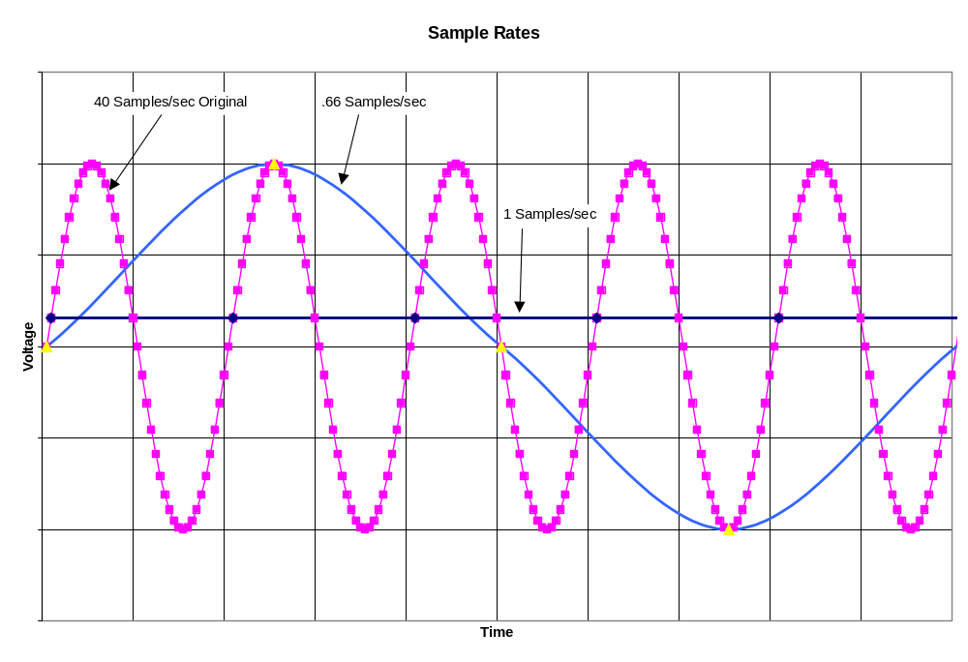

B. Symmetrical Samples
Data should be extracted symmetrically. If only the first 4 samples of each cycle shown above are selected, the extracted signal will not represent the original. This problem presents itself when selecting sample rates. For example if the major frame is as follows:

Major frame Matrix Parameters
40 words / minor frame
40 frames / major frame
10 bits / word
400 Kbit

Possible minor frame intervals and symmetrical data extraction rates for the described frame are:

Minor Frame Interval | Sample Rate (samples/second) | Possible Extraction Rates for Symmetrical Sampling
1 | 1000 | 25,50,100,200,250,500,1000
2 | 500 | 25,50,100,500
4 | 250 | 25,50,250
5 | 200 | 25,50,100,200
8 | 125 | 25, 125
10 | 100 | 25,50,100
20 | 50 | 25, 50
40 | 25 | 25

The chart below shows the possible extraction rates for a data item with a minor frame interval of 8. Assuming the first data word occurs in frame #1, minor frames containing data are 1, 9, 17, 25, and 33. Notice that the only possible extraction rates that produce symmetrical samples are 25 samples/sec and 125 samples/sec.

Minor Frame Interval | Extract Rate | Minor Frames Extracted | Symmetrical | Missing Frames
8 | 25 | 1 | Yes | 9, 17, 25, 33
8 | 50 | 1,17 | NO | 9, 25, 33
8 | 75 | 1, 17, 25 | NO | 9, 33
8 | 100 | 1, 9, 17, 33 | NO | 25
8 | 125 | 1, 9, 17, 25, 33 | Yes | --

Data can be extracted at non-symmetrical rates. The frame from which the data was extracted can be included in the output file by selecting Frame from the Data Parameters menu and enabling Write Frame Number.

